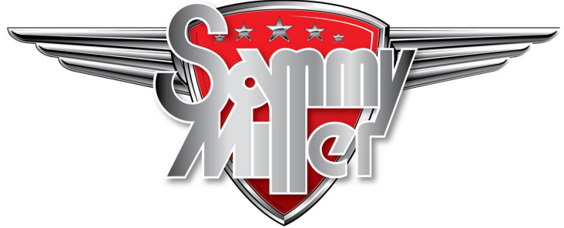  

**Events List for 2025**

|  |  |
| --- | --- |
| **5th/6th April**  **Sunday April 27th** | **Ducati Uk Roadshow 2025**  **Royal Enfield Day** |
| **Sunday May 4th**  **Sunday May 11th**  **Wed May 21st**  **Saturday May 24th**  **Sunday May 25th**  **Sunday June 1st**  **Sunday June 8th**  **Sunday June 15th**  **Saturday June 21st**  **Sunday June 22nd**  **Sunday July 6th**  **Sunday July 13th**  **Sunday July 20th**  **Sunday July 27th**  **Sunday Aug 3rd**  **Sunday Aug 10th**  **Sunday Aug 17th**  **Sunday Aug 31st**  **Sunday Sept 7th** | **Spring Auto Jumble**  **Annual Rickman Day**  **Norton Owners Club Ride In**  **Bultaco Owners Club UK Bike Meet**  **Goldwing Gathering**  **VJMC and Japanese Bike Bonanza**  **BSA Owners Club Day**  **Harley Davidson Meet**  **TRX 850 Owner’s Club 30th Anniversary**  **Ladies Day**  **Smokin to Sammy’s – a 2 Stroke Event**  **Annual Scooter Day**  **Honda Owners Classic Bike Show**  **National BMW Airhead Day**  **Triumph Owners Meet**  **Summer Auto Jumble**  **All Things Italian**  **British Bike Day**  **Kickback Custom Bike Show**  **We look forward to seeing you, any event donation gratefully received.** |